Phase 1 — SQL Analytics Layer (Business Intelligence Foundation)

Tasks
- Create a new database schema for the hospital system.
During Phase 1 ingestion, the approved_amount field in the raw billing data was loaded as text due to inconsistent formatting and missing values in the source CSV. Additionally, the Vacareum MySQL environment restricted UPDATE operations, preventing in-place data correction.
To maintain data integrity while preserving the raw source as an immutable layer, a cleaned transformation layer (billing_clean) was created. This table standardizes financial fields into numeric types and normalizes missing approvals to zero, enabling accurate computation of revenue realization ratios, rejection rates, and payment delay metrics. This layered approach mirrors real-world data lake and warehouse practices, where raw data is preserved and cleaned, analytics-ready tables are derived for reporting and modeling.
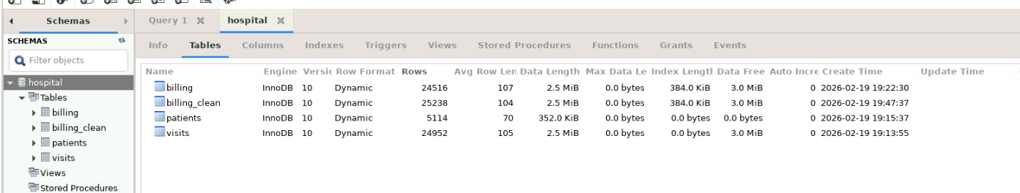
- Define SQL tables: patients, visits, and billing with appropriate data types.
- Define primary keys and foreign key relationships between tables.
- Document which queries benefit from which indexes.
- 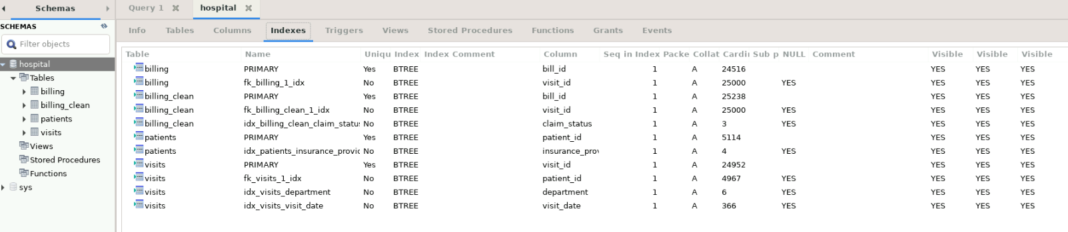
Analysis
- Operational Analysis

  - Retrieve the top 10 departments by total visit volume.
--1. Retrieve the top 10 departments s by total visit volume
-- Business purpose : identify high demand departments to support capacity/operational planning

select department, count(*)
from hospital.visits
group by department
order by count(*) desc
limit 10;

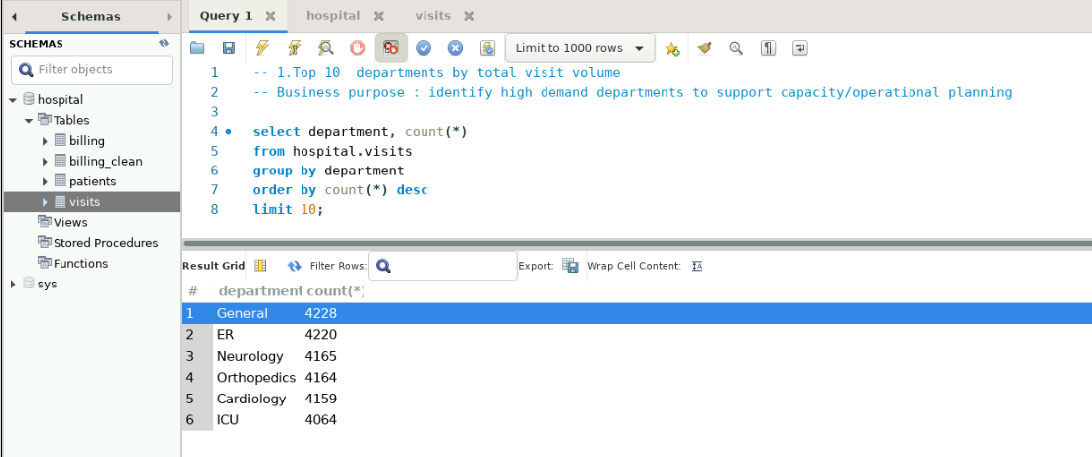
  - Identify the top 5 departments with the highest average length of stay.
-- 2.Top 5 departments with highest avg length of stays
-- Business purpose: Detect departments with operational inefficiencies or complex cases

select department, round(avg(length_of_stay_hours),2) as avg_len_of_stay
from hospital.visits
group by department
order by avg_len_of_stay desc
limit 5;

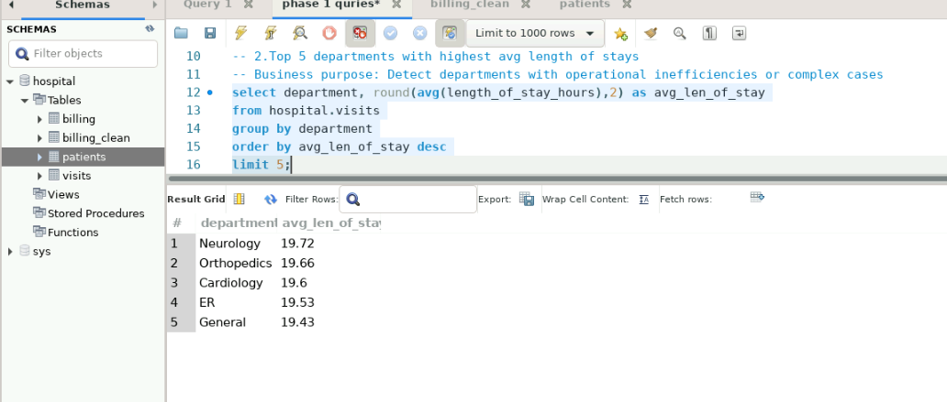
  - Find the percentage of High Risk visits per department.
-- 3. % of high risk visits per department
-- Buisness purpose: Understand clinical risk concentration across departments

select department, round(100*sum(case when risk_score='High' then 1 else 0 end)/count(*),2) as high_risk_per
from hospital.visits
group by department
order by high_risk_per desc;

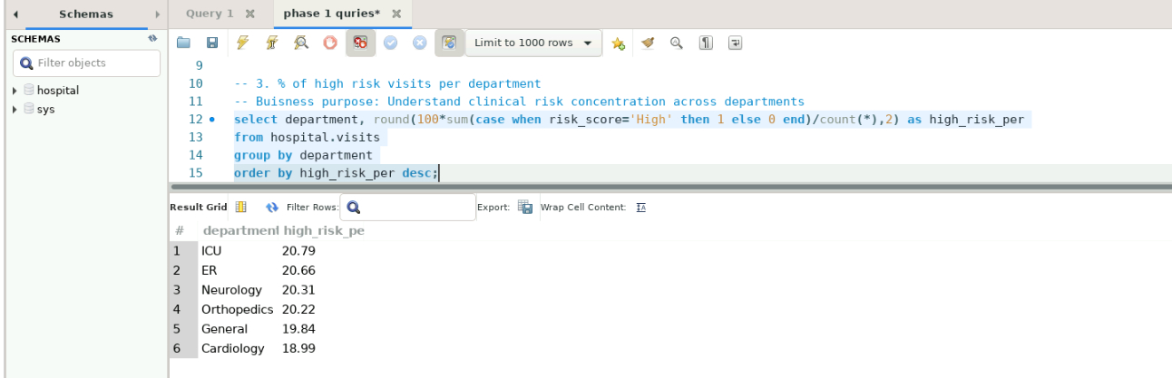

  - Determine the average number of visits per patient by city.
-- 4.average number of visits per patient by city
-- Business purpose: Identify cities with higher repeat beahaviour and service demand.

select p.city,round(count(v.visit_id)/count(distinct p.patient_id),0) as avg_visit_per_patient
from hospital.patients p join hospital.visits v on p.patient_id = v.patient_id
group by p.city
order by avg_visit_per_patient;

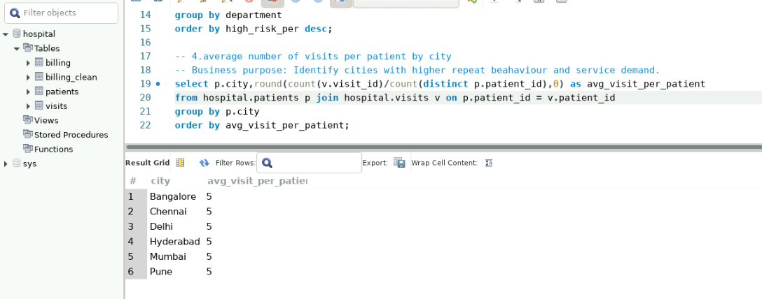

  - Identify doctors handling the highest number of High Risk visits.
-- 5.Doctors handling the highest number of high risk visits
-- Business purpose: Identify doctors handling complex cases for workload balancing and support

select doctor_id,count(*) as high_risk_visit
from hospital.visits
where risk_score='High'
group by doctor_id
order by high_risk_visit desc
limit 10;

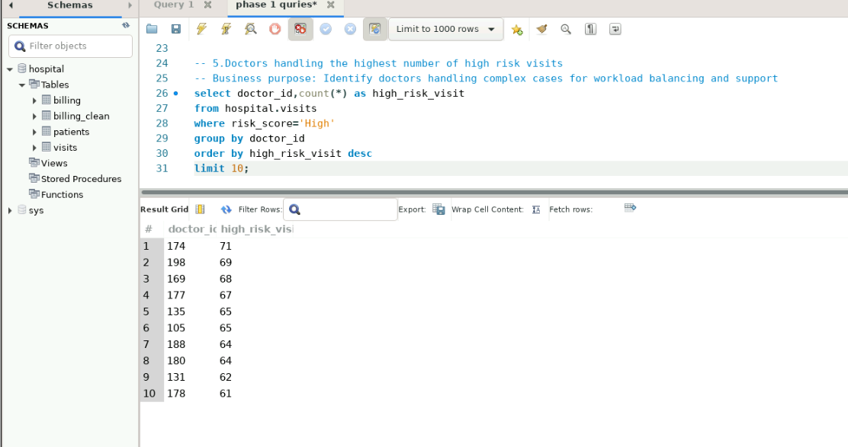
- Financial Analysis
  - Retrieve the top 10 insurance providers by total billed amount.
-- 6. top 10 insurance providers by total billed amount
-- Business purpose: Identify key revenue contributing revenue partners

select p.insurance_provider, sum(b.billed_amount) as total_billed_amount
from hospital.billing_clean b join hospital.visits v on b.visit_id = v.visit_id
join hospital.patients p on v.patient_id = p.patient_id
group by p.insurance_provider
order by total_billed_amount desc
limit 10;

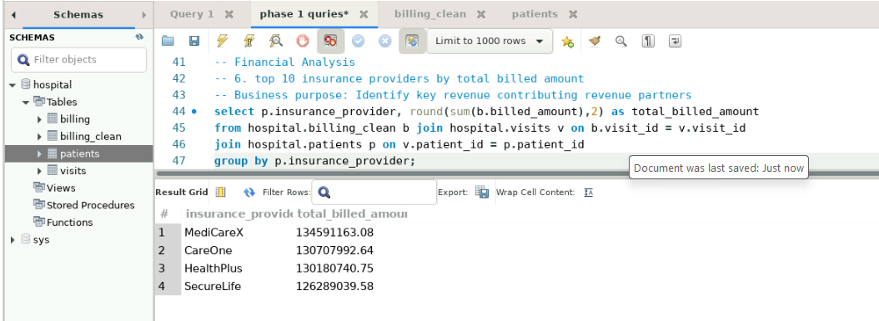
  - Identify the top 5 insurance providers with the highest claim rejection rate.
-- 7. Identify top 5 insurance companies with highest rjection rate
-- Business Purpose: Idenity payers revenue loss due to claim rejections

select p.insurance_provider , round(100*sum(b.claim_status='Rejected')/count(*),2) as rejection_rate_per
from hospital.billing_clean b join hospital.visits v on b.visit_id = v.visit_id
join hospital.patients p on v.patient_id = p.patient_id
group by p.insurance_provider
order by rejection_rate_per desc
limit 5;

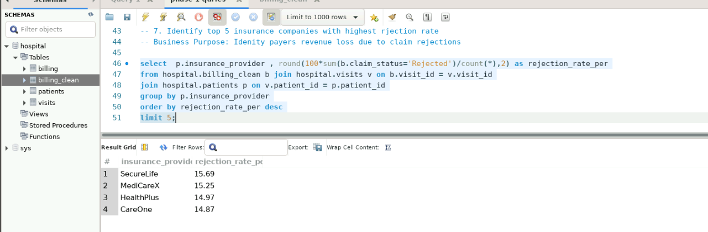

  - Find the average payment delay (payment_days) by insurance provider.
-- 8. average payment delay in days by insurance providers
-- Business Purpose: Understand the cashflows

select p.insurance_provider,round(avg(b.payment_days),0) as avg_payment_days
from hospital.billing_clean b join hospital.visits v on b.visit_id = v.visit_id
join hospital.patients p on v.patient_id = p.patient_id
group by p.insurance_provider
order by avg_payment_days desc;

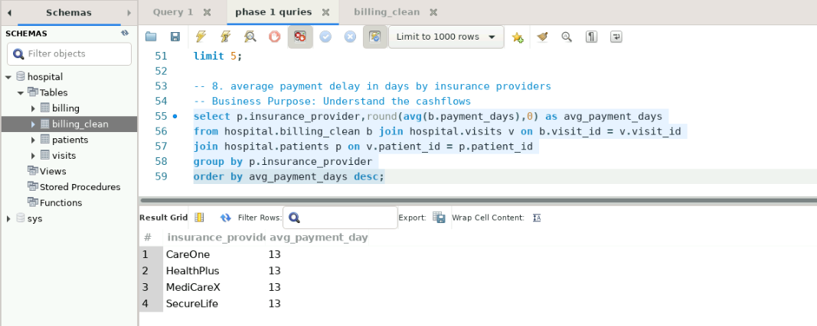

  - Calculate the revenue realization ratio (approved_amount / billed_amount) by department.
-- 9. revenue realization ratio by department
-- Business Purpose: Measure billed revenue actually realized

select v.department, round(sum(b.approved_amount)/ nullif(sum(b.billed_amount),0),2) as revenue_realization_ratio
from hospital.billing_clean b join hospital.visits v on b.visit_id = v.visit_id
group by v.department
order by revenue_realization_ratio asc;

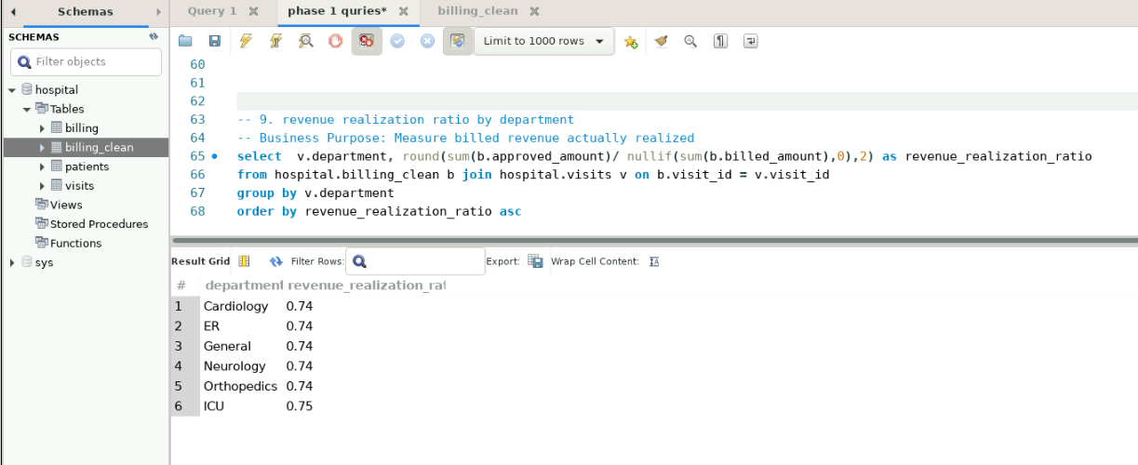

  - Identify visits where billed_amount is high but approved_amount is zero or missing.
-- 10. Visits with high billed amount but zero or missing approved amount
-- Business purpose: Detect revenue leackage

select * from hospital.billing_clean
where billed_amount > 10000
and (approved_amount is null or approved_amount = 0)
order by billed_amount desc;

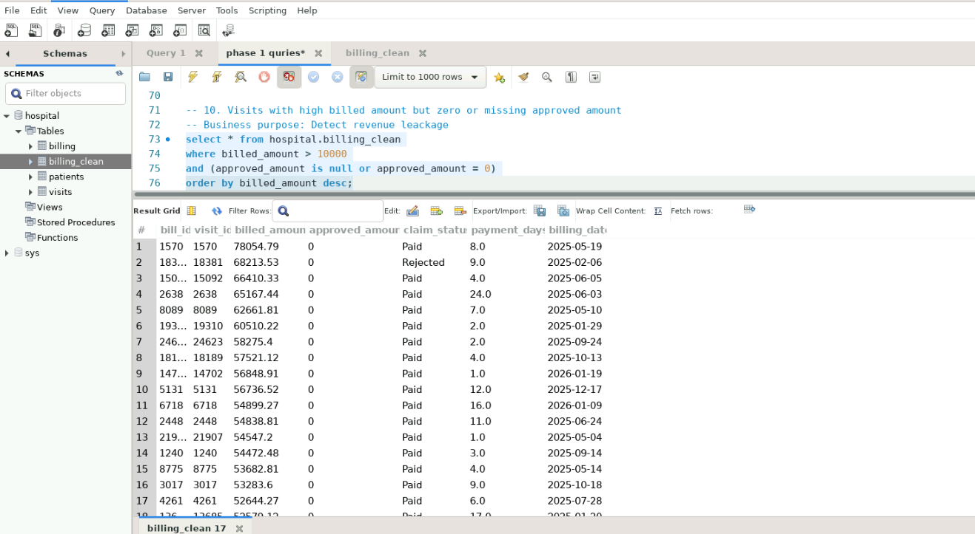

- Data Quality and Integrity Checks

  - Detect visits that do not have a corresponding billing record.
-- 11. Visits that donot have a corresponding billing record
-- Business purpose Detect operation leackage

select b.visit_id
from hospital.visits v left join hospital.billing_clean b on v.visit_id = b.visit_id
where b.visit_id is null;

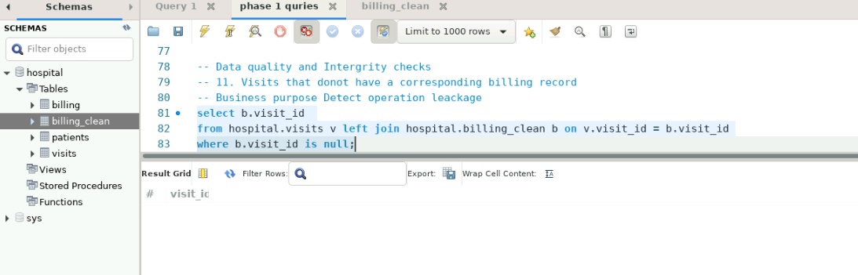

  - Detect billing records that do not have a corresponding visit.
-- 12. Billing records that donot have corresponding visit
-- Business purpose: identify orphan financial records

select b.bill_id
from hospital.billing_clean b left join hospital.visits v on v.visit_id = b.visit_id
where v.visit_id is null;

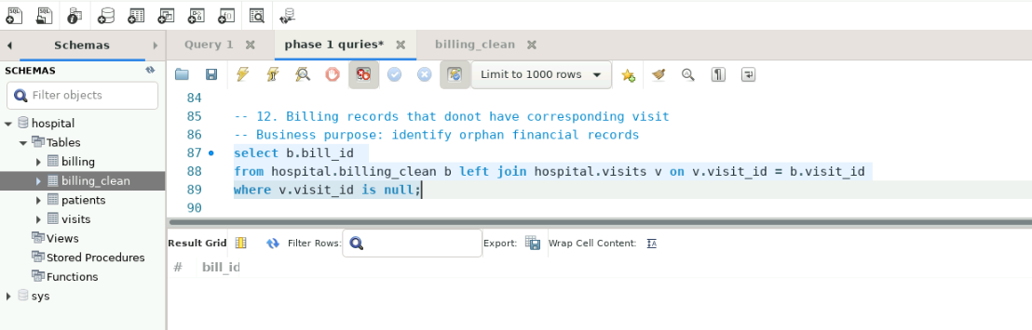

  - Identify patients with duplicate patient_id values.
-- 13. Patients with duplicate patient ids
-- Business Purpose: primary key violations

select patient_id ,count(*)
from hospital.patients
group by patient_id
having count(*)>1;

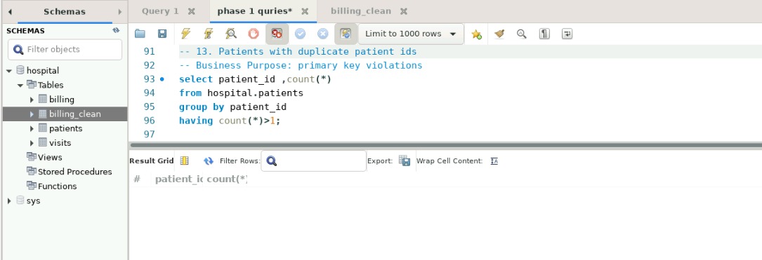

  - Find records with missing or invalid length_of_stay_hours or payment_days.
-- 14. Records with missing or invalid length of stay hours
-- Business purpose: Detect unreliable financial metrics

select *
from hospital.visits
where length_of_stay_hours is null
or length_of_stay_hours < 0;

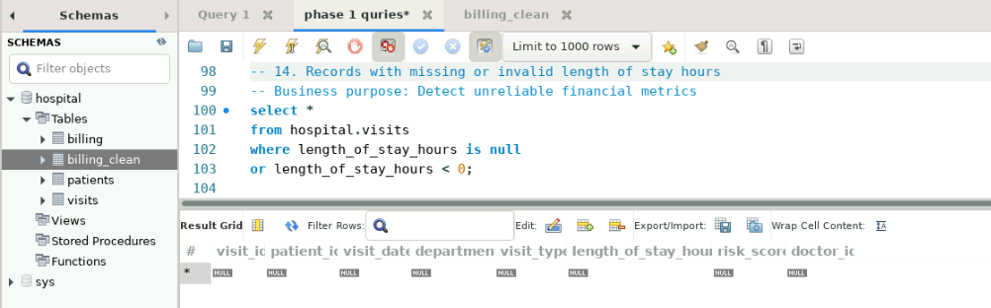

-- 15. Records with missing or invalid payment days
-- Business purpose: Detect unreliable financial metrics

select *
from hospital.billing_clean
where payment_days is null
or payment_days < 0;

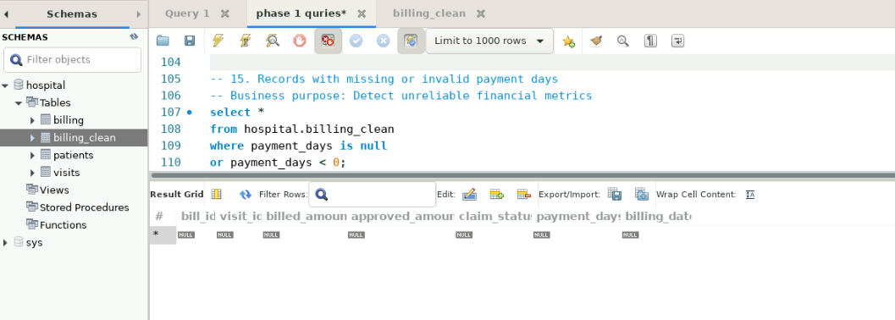

  - Identify visits linked to patients with missing insurance provider information.
-- 16 Visits linked with missing insurance providers
-- Business impact: Identify incomplete patient finacial profiles

select v.visit_id, p.patient_id
from hospital.visits v join hospital.patients p on v.patient_id = p.patient_id
where p.insurance_provider is null
or p.insurance_provider = '';

